# CSE4001 - Parallel and Distributed Computing

# Lab 21+22

# Lab Assignment- 5

# Submitted by: Alokam Nikhitha

# Reg No:19BCE2555

# QUESTION:

Write a C program to handle message passing in the MPI application interface using Group Operators: Scatter and Gather.

# CODE:

#include <mpi.h>

#include <stdio.h>

#include <stdlib.h>

int main(int argc, char **argv) {

int size, rank;

MPI_Init(&argc, &argv);

MPI_Comm_size(MPI_COMM_WORLD, &size);

MPI_Comm_rank(MPI_COMM_WORLD, &rank);

int *globaldata=NULL;

int localdata;

if (rank == 0) {

globaldata = malloc(size * sizeof(int) );

for (int i=0; i<size; i++)

globaldata[i] = 3*i+2;

printf("Processor %d has data: ", rank);

for (int i=0; i<size; i++)

printf("%d ", globaldata[i]);

printf("\n");

}

MPI_Scatter(globaldata, 1, MPI_INT, &localdata, 1, MPI_INT, 0, MPI_COMM_WORLD);

printf("Processor %d has data %d\n", rank, localdata);

localdata *= 2;

printf("Processor %d doubling the data, now has %d\n", rank, localdata);

MPI_Gather(&localdata, 1, MPI_INT, globaldata, 1, MPI_INT, 0, MPI_COMM_WORLD);

if (rank == 0) {

printf("Processor %d has data: ", rank);

for (int i=0; i<size; i++)

printf("%d ", globaldata[i]);

printf("\n");

}

if (rank == 0)

free(globaldata);

MPI_Finalize();

return 0;

}

# Code Snippets:

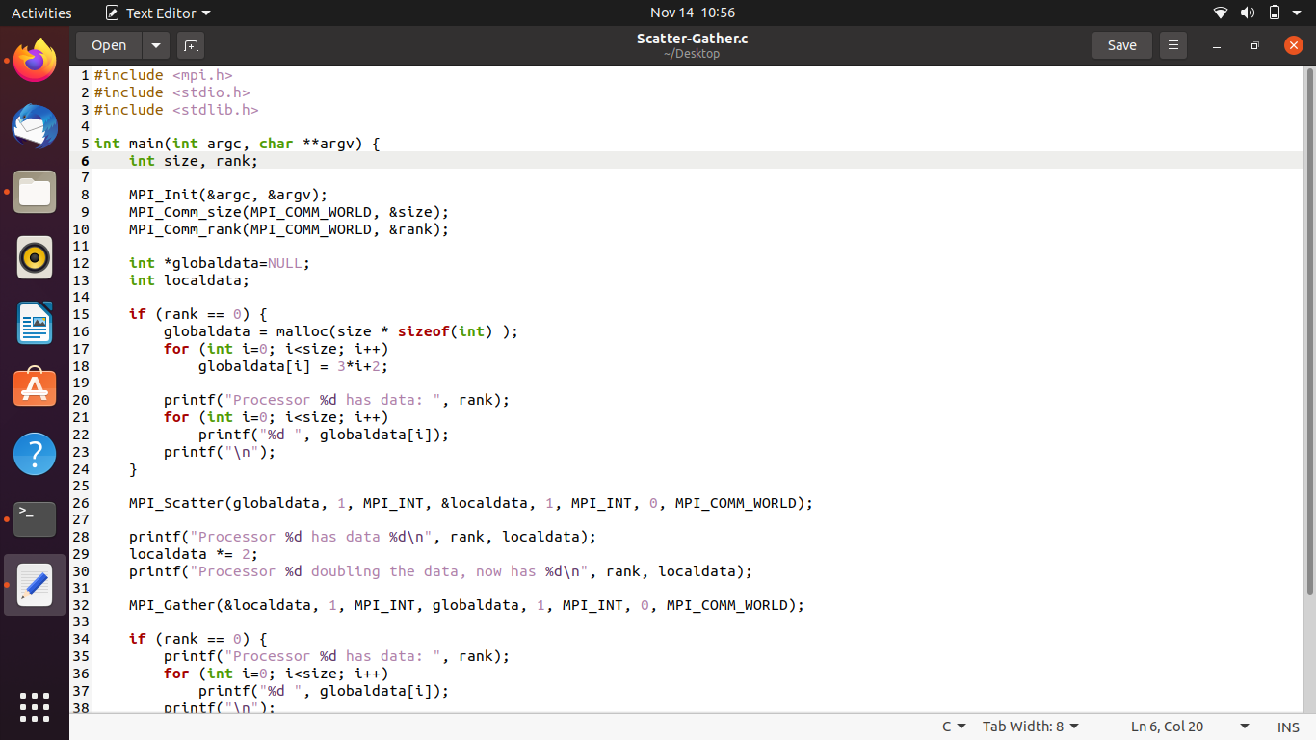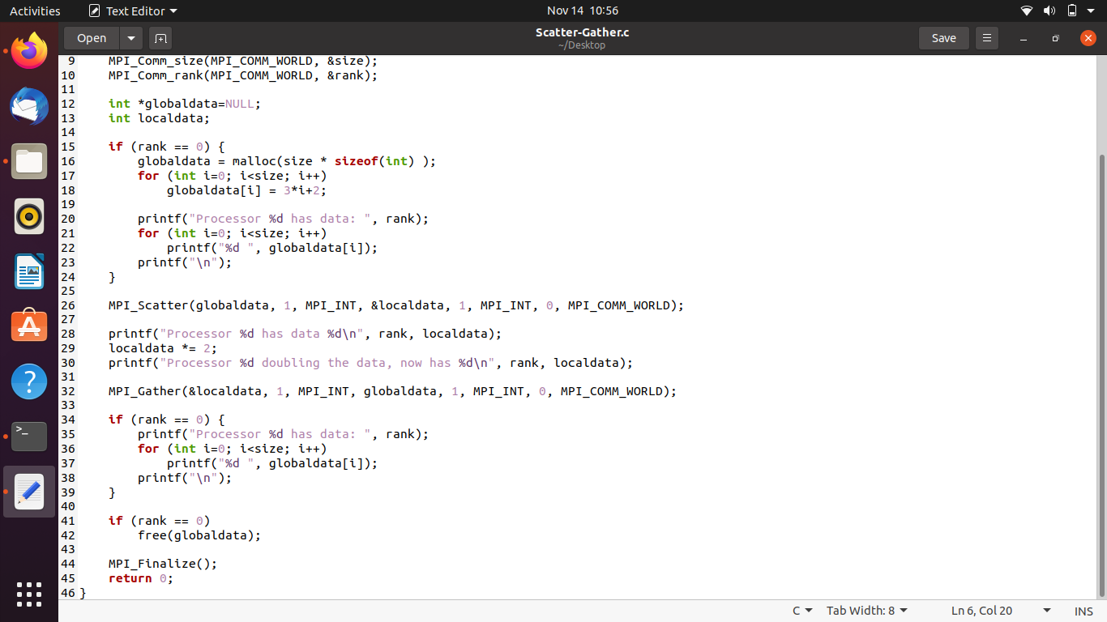

# OUTPUT:

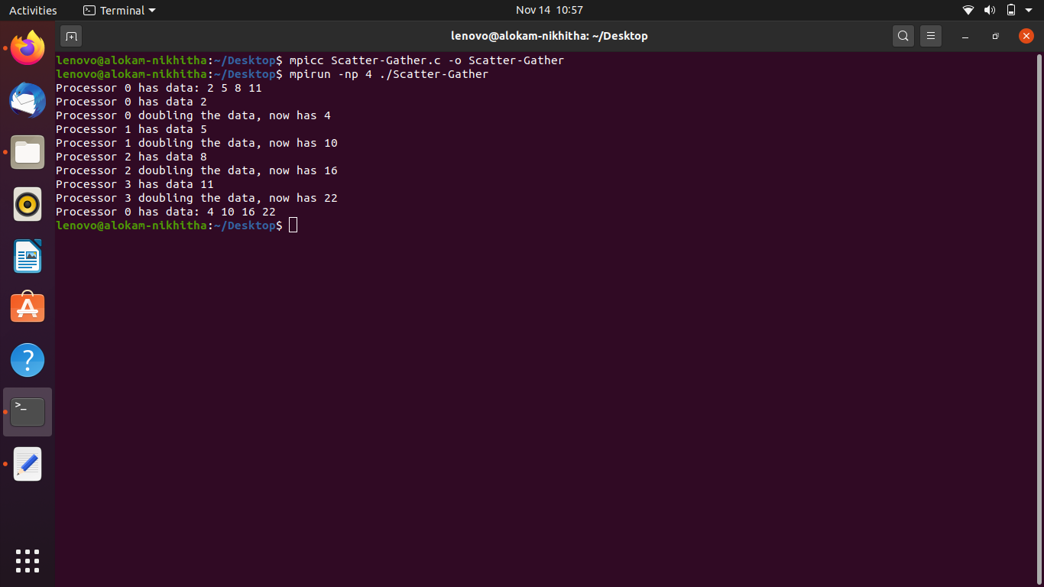

**OUTPUT WITH CODE:**

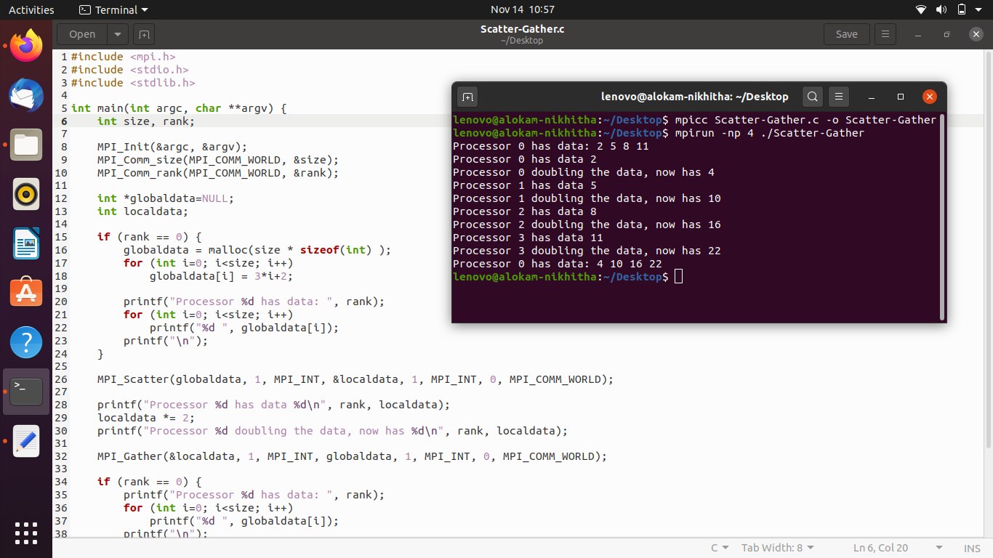

Result and Inferences:

* We are passing the messages using MPI_Scatter and MPI_Gather Commands.
* Initialized the value in array as 3i+2 where i is the index of the array.
* We doubled its value during using different allocation named ldata.
* We used MPI_Gather command to read data of ldata allocation.
* Finally, We print the values of our initial allocation to check for the results.